Timetable Generator UI Design:

# HOMEPAGE:

## When the user goes to the homepage:

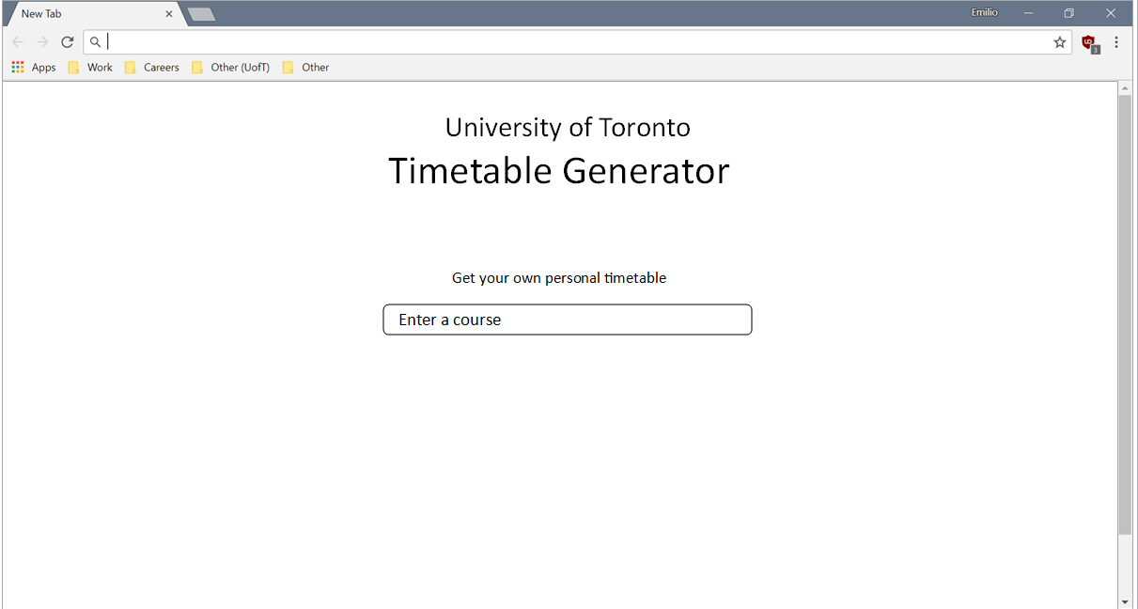

## When the user starts typing a course in the search box:

The user must enter the first three letters of the course code

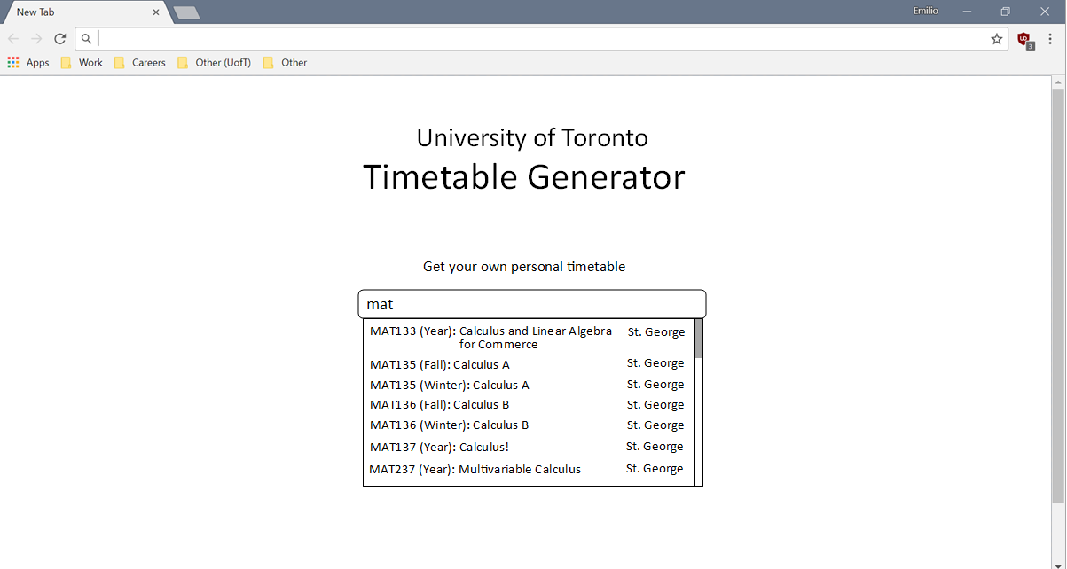

## When the user selects a course

The webpage scrolls down and finds the Fall/Winter course table. A “Generate timetable” will appear, as long as there is at least one course selected.

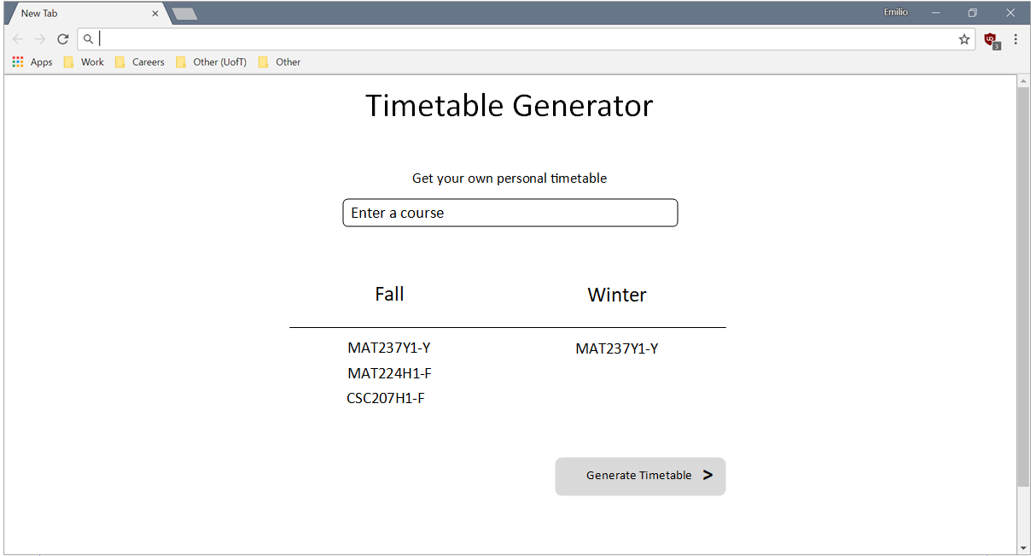

## When the user still wants to add more courses:

The user has to enter the first three letters of the course code into the text box, and the results will show.

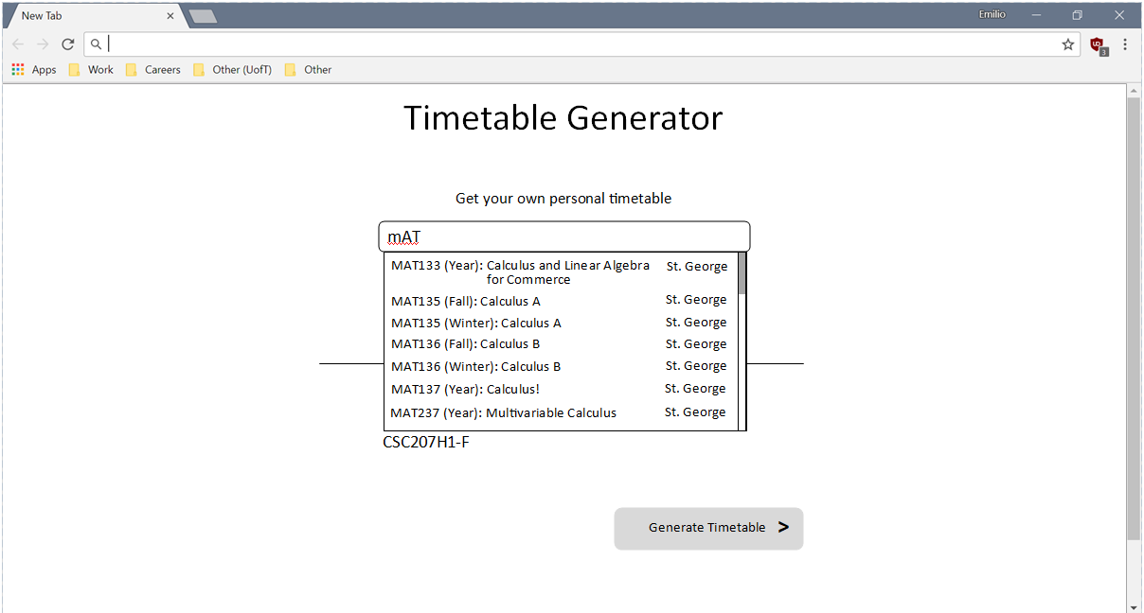

## When the user wants to delete a course:

Hover over the course, and it will show a delete button. When the mouse clicks on the delete button, remove the course. If it is a year course, remove the course in both the Fall and Winter sessions.

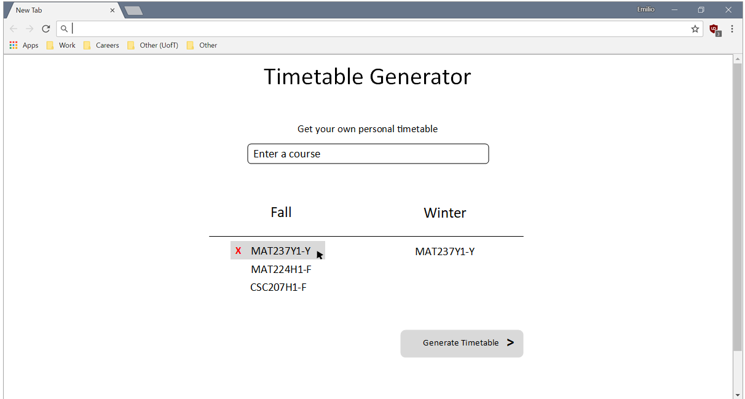

## When the user generates a timetable:

When the user clicks on the “Generate timetable” button, it takes some time for the server to generate timetables. Display a waiting dialog while the web page is waiting to receive its HTTP request.

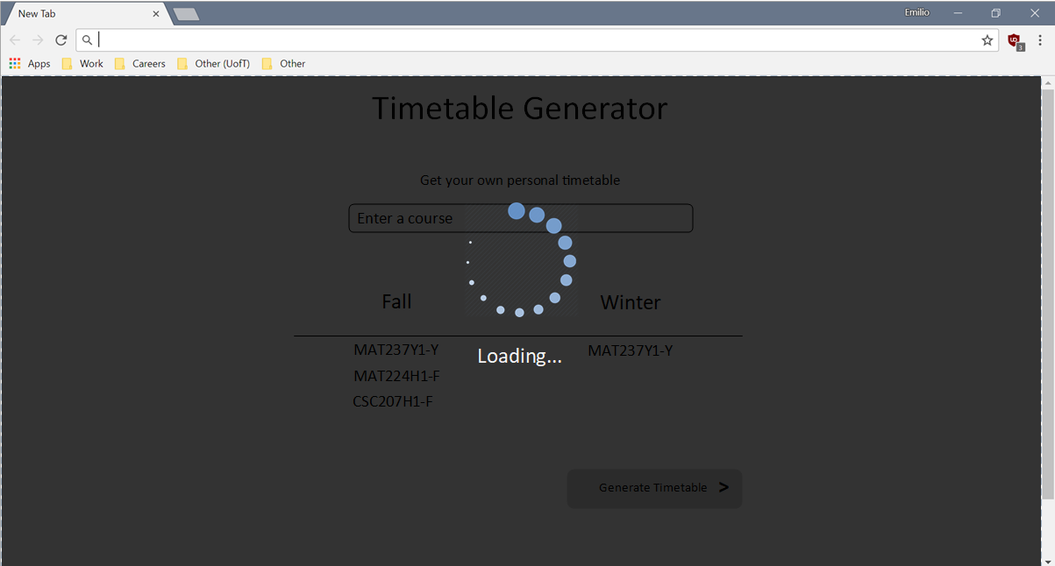

## When no timetable can be made:

Clicking on the “Retry” button will regenerate the timetables again. This will also show the Loading page again. Clicking on the “Reselect courses” will close the overlay panel.

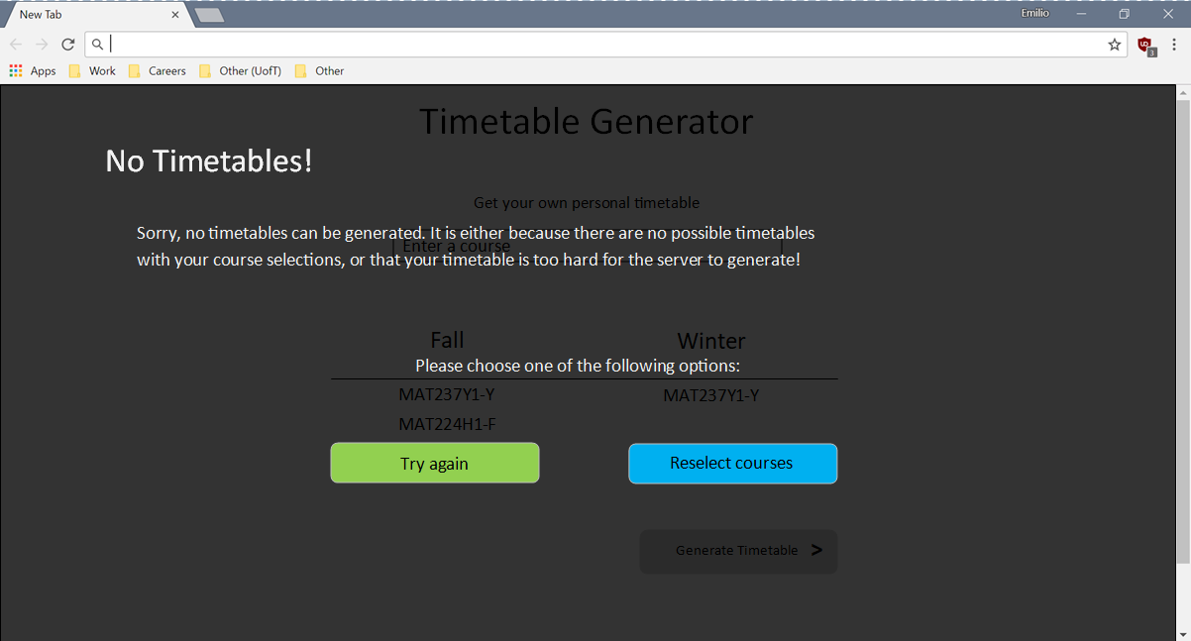

# TIMETABLE GENERATOR APP:

## After the timetables were generated:

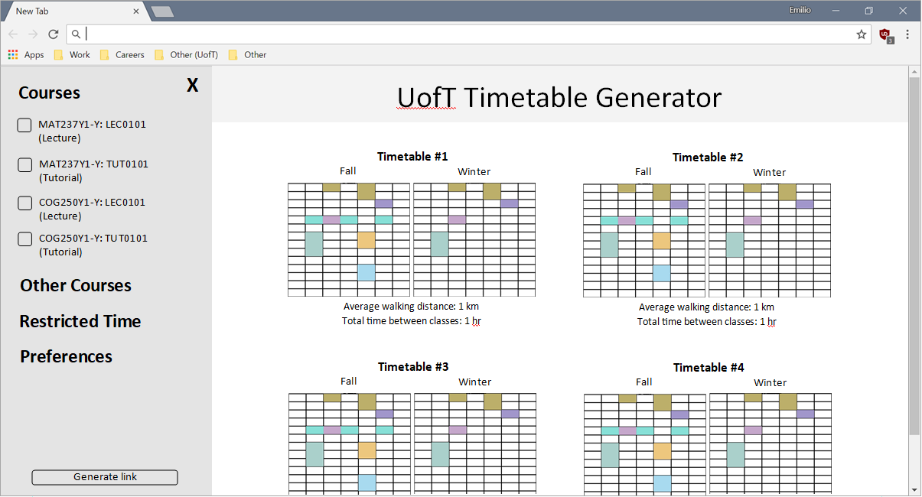

## Hiding the side navigation bar:

